Neighborhood Clean-Up
A Shelton Clean Sweep Event

A litter clean-up work party is being organized for our neighborhood. Please join us and make this annual Shelton Clean Sweep a success!

Our clean-up will be part of a city-wide effort to ride our streets, parks, waterways, and schools of litter. More information about Shelton Clean Sweep can be found online at www.DontTrashShelton.org
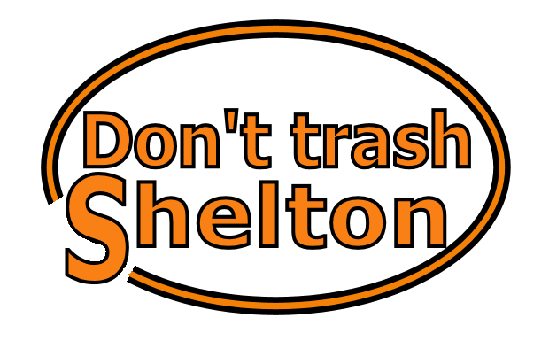

Date: _____________________

Time: _____________________

Place to meet: __________________________________

Location(s) to be cleaned:

___________________________________________________

Event organizer and contact info:
______________________________________________________

Comments:

